# JS Advanced: Exam 18.11.2018

# Problem 1. Form Acceptance

### Use the index.html and app.js files to solve this problem.

### Note: You can't and you have no permission to change directly the given html code (index.html file).

### Your Task

**Write the** **missing JavaScript code** to make the **Acceptance form** work as expected.

When **all fields (company, product, quantity and scrape)** are **filled with correct input.**

**- Company and product needs to be non-empty strings.  
- Quantity and scrape needs to be numbers.**

Upon pressing the “**Add it**” button, a new stock (**product**) should appear in the warehouse list,   
on following format:  
**[{companyName}] {productName} – {productQuantity} pieces {outOfStockButton}**  
**Keep in mind that** you need to add the available quantity of the product that **is not scrape**. In these cases when the available product quantity is less or equal to zero (<= 0) you should **not add it** to the warehouse list.

**If** one or all fields **are not filled** you should do **nothing**!

**In the cases when quantity and scrape are numbers, the quantity value always will be greater or equal to the** **scrape value;**

The input fields should be **reset** when the "Add it" button is **clicked**!

When the **Out of stock** button is clicked, the current product should **be removed** from the warehouse list.

### Submission

Submit only your **acceptance()** function.

### Examples

**Before we accept any product:**

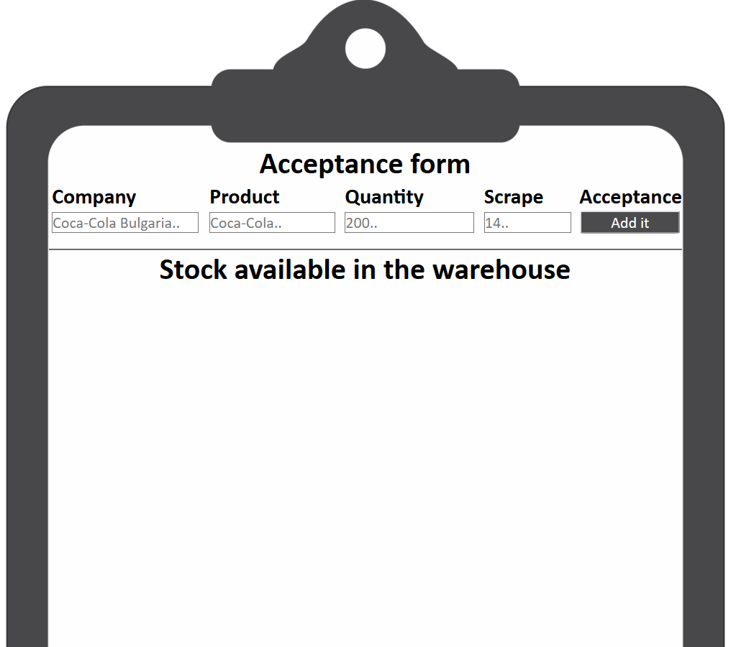

**Code structure before we accept any product:**

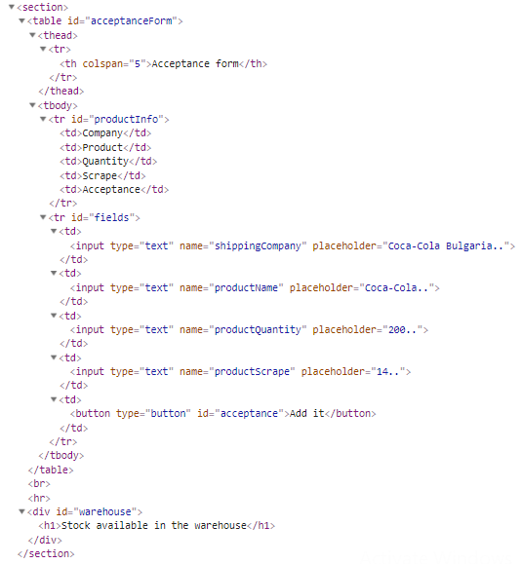

**Before we hit the “Add it” button with correct values for all of the fields:**

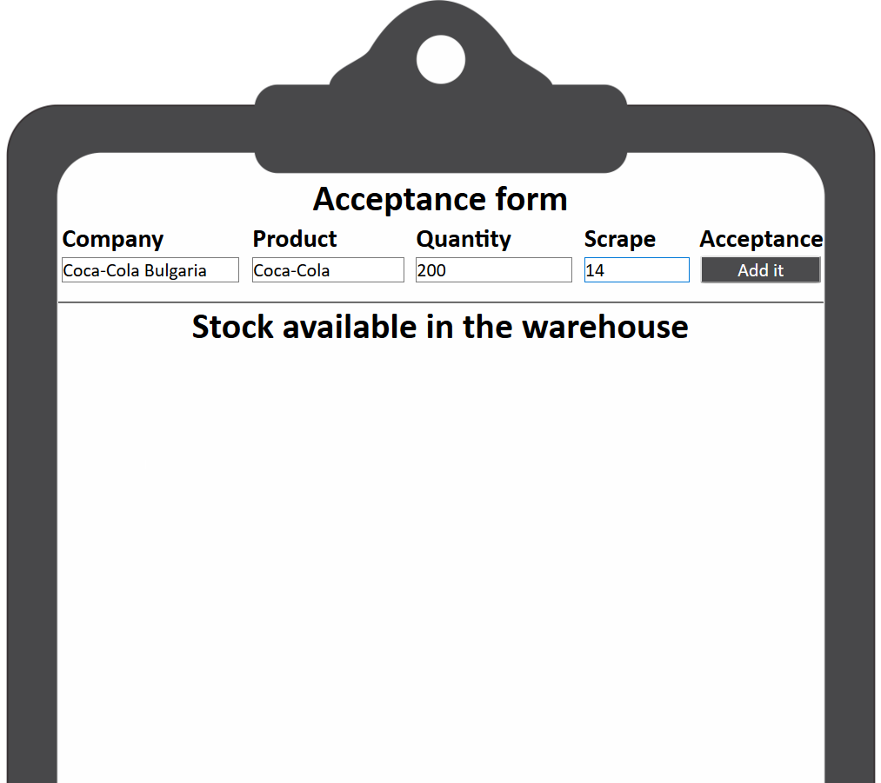

**When we hit the “Add It” button:**

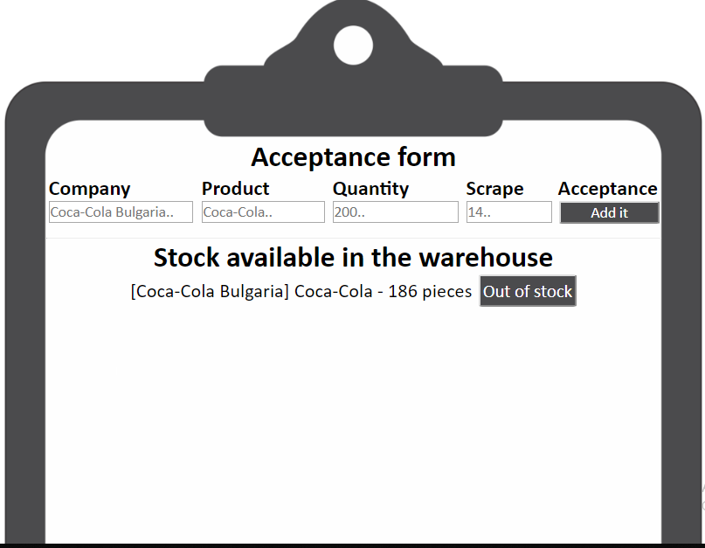

**Code structure when we hit the “Add It” button and we added successfully a new product to the warehouse list:**

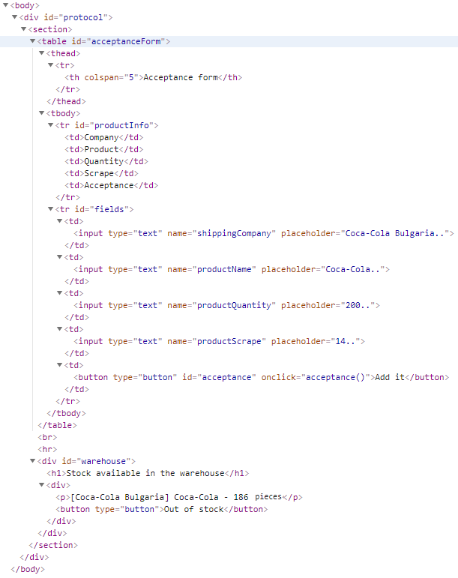

**If we hit the Out of stock button**, the result and code structure needs to be like the examples into the beginning (before we add this product to the warehouse list) **=== The div that contain the clicked button should be remove from the warehouse list.**

*GOOD LUCK… c(:*